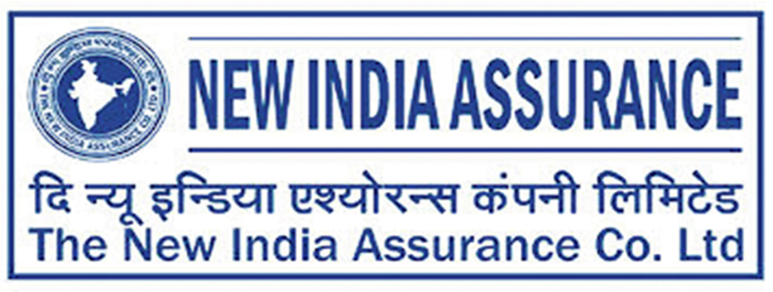

Regd. & Head Office: New India Assurance Bldg. 87, M.G. Road, Fort, Mumbai - 400001

PUBLIC NOTICE

TO THE HEALTH INSURANCE POLICYHOLDERS OF THE NEW INDIA ASSURANCE COMPANY LIMITED

We wish to notify our Health Insurance Policyholders that M/s Paramount Insurance TPA Pvt. Ltd. has merged with M/s Medi Assist Insurance TPA Private Limited. Consequently, the services previously provided by M/s Paramount Insurance TPA Pvt. Ltd. will be transitionally available through MediAssist Insurance TPA, effective from June 1, 2026.

Should you require any further information or clarification concerning your policy renewal, kindly get in touch with your respective policy servicing office.

Inconvenience caused if any, is sincerely regretted.

THE NEW INDIA ASSURANCE COMPANY LIMITED,
MUMBAI
IRDAI REGN. No. 190 - CIN No.: L66000MH1919GOI000526

